Mitigating Eutrophication and Toxic Cyanobacterial Blooms in Lakes By
Managing Nutrients
Name
Institution
Date

Mitigating Eutrophication and Toxic Cyanobacterial Blooms in Lakes By
Managing Nutrients
Abstract
Pollution is among the main controversial issues in the current days. Pollution can be understood as the introduction of harmful materials to the environment. The pollutants are of wide ranges and can affect either water, air, or water. Pollutants are substances that pose undesired effects on the environment. Water pollution has greater effects on marine life, and these effects are even extended to terrestrial organisms. Water pollution has led to the destruction of biodiversity, and the aquatic ecosystems are depleted. The main effect of water pollution is eutrophication. Eutrophication is caused by the presence of nitrates and phosphates in slow-moving water, thus initiating cyanobacteria growth. The algal blooms cause depletion of oxygen and prevent oxygen from entering into water systems. The main effects of this problem are initiating the death of aquatic biota. Humans also face significant health effects when they drink intoxicated water. People's main reviews regarding eutrophication are that human activities, including poor management of sewage, poor disposal of domestic wastes, use of organic fertilizers, and aquaculture. Mitigation practices for eutrophication have been initiated, and the primary ones include UNEP and EPA is committed to eliminating the problem. The law enforcement agencies have been taking action against companies and people who work against policies governing eutrophication. The future of eutrophication and reducing deaths related to algal blooms depends on the action taken to prevent the development of harmful cyanobacteria. There is a need for quality education to more specialists to deal with eutrophication and aquatic issues, prevent algal bloom-related deaths, and promote quality human health.

Introduction
According to Ding et al. (2018), eutrophication refers to the gradual increase in the concentration of mineral ions, especially nitrogen, phosphorus, and sulfates, in an aging aquatic ecosystem like lakes. Eutrophication results from predominant human action due to their increased dependency on nitrates and phosphate-rich products. Scientists have described eutrophication as the most serious environmental issue affecting aquatic life. Eutrophication developed following the industrial revolution. In this regard, human activities have a greater impact in initiating dangerous eutrophication. Take an instance of the need for farmers to produce industrial raw materials that have accelerated fertilizer usage for quality yields. When drained to the lakes, fertilizers have phosphates, resulting in Eutrophication (Ding et al., 2018). The point source pollution like discharging sewage treatment plant or industrial plant wastes in the water bodies. The concentrated animal feeding operations contribute to water pollution since they contain phosphorus and nitrogen nutrients. The animal feed products find their way into the lakes by recurring cyanobacterial and algal blooms. Eutrophication can be associated with natural events like floods the natural flow of rivers and streams, leading to excessive nutrients from the land to the water bodies.
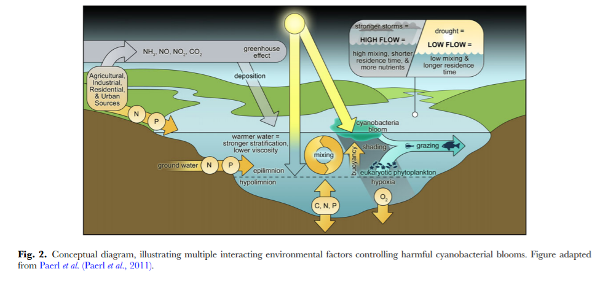
Eutrophication is a controversial topic, and people deserve education on how they are killing their universe by initiating water pollution. This paper is focused on giving the history of eutrophication, highlighting the public viewpoints of the issue, accessing major efforts to mitigate the eutrophication, the strengths and weaknesses of mitigating eutrophication, and offering recommendations on better restoration efforts.
Review and Synthesis
- History of Eutrophication
The term eutrophication becomes common in the 1940s when it was discovered that over one year, plants' nutrients resultant from industrial actions and agriculture had resulted in variations in water nature and affected the biological character in the water bodies. Almost all the parts of the globe have experienced eutrophication. In the 20th century, this problem was more pronounced in England and Wales, especially in the 1980s (Demeke, 2016). In this era, the public understood the widespread of toxic blue-green bacterial blooms—cyanobacteria developed in greater heights within the lakes. Scientists have discovered that cyanobacteria are not typical bacteria due to their multicellular nature and can support long food chains of cells. Eutrophication is more pronounced in the coastal waters. The increased eutrophication rates led to the development of conferences on protecting the North Sea. In the sea, the input of phosphorus was found to be 50% between 1985 and 1995 (Demeke, 2016). Nitrogen was as well much higher on the coastal water, and this contributed development of algal blooms. The history of eutrophication can be assessed in the following dimensions.
- Industrial Revolution
The industrial revolution can be traced back to 1760, and it commenced in Britain and later spread to other parts of the world. By 1840, many top nations in the world had adopted the industrial revolution. This era was the beginning of setting industries, and later in the 1940s, the industries were not catering much to environmental welfare (Ding et al., 2018). The continual disposal of industrial wastes in the water bodies led to the accumulation of nitrogen and phosphorus. The algal blooms started developing the death of the aquatic animals. In this period, research on eutrophication was insufficient, and many stereotypes revolved around the issue.
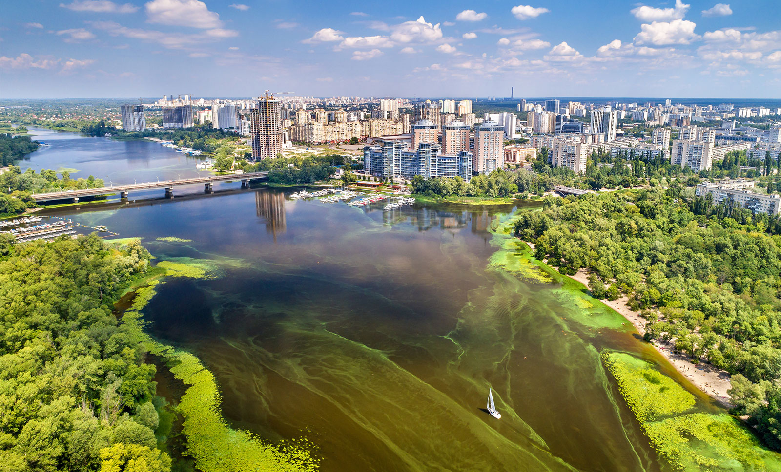
Fig1.0: Eutrophication in Urban Center
- Agricultural Development
Agricultural development has been increasing with the need to increase food production to the ever-increasing world population. Fertilizers then gained significance and were widely applied in farms. Chemical fertilizers became much common between 1960 and 1990 which bear synthetic nitrogen had increased multiple times (Huang et al., 2018); the fertilizers are commonly applied in excess in crop need. The excessive nutrients are lost in volatilization, and others get in the ground through leaching to the groundwater. Approximately 20% of the nitrogen lost from in the soil is leached into groundwater (Huang et al., 2018). The greater percentage of nitrogen applied on the plants is lost to the environment by volatilization in ammonia form. During the rainy seasons, traces of phosphorus and nitrogen in the soil are lost, and great eutrophication cat occurs with ease. Agricultural activities near the river banks and around water bodies are much common in the current days. The farmers use fertilizers, manure, and pesticides that have traces of nitrogen and phosphorus. Overflowing water passes these nutrients directly to the water bodies increasing the chances of developing algal blooms.
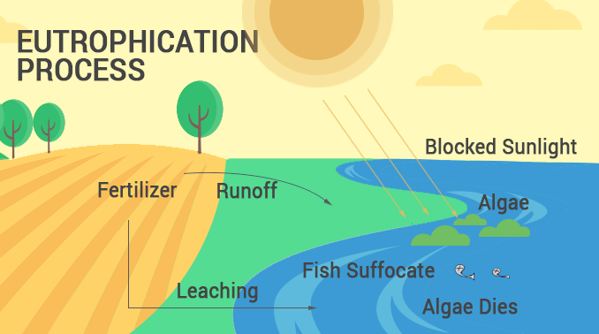
Fig 1.1: Eutrophication Process (Earthhow, 2021).
Between 1990 and 2002, China recorded a 127% increase in meat production (Ding et al., 2018). The animal waste products were not well disposed of, and this accelerated eutrophication as the animal wastes contain nitrates and phosphate molecules. Aquaculture is a modern of fish keeping in the water bodies and using them for commercial purposes. Aquaculture is growing to be a major source of nutrient pollution (Xiao et al.,2020). By the start, fish farming was done on the separate pond from the main water bodies, but the current is fish farming has been transformed to enable keeping the fish within the main water bodies. Marine fish and shrimps are commonly kept in net pens or cages. The farms produce concentrated amounts of phosphorus and nitrogen from fish foods and other organic products. According to Huang et al. (2018), in one ton of fish within aquaculture, 66 kilograms of nitrogen waste are produced, and at least 7.2 kilograms of phosphorus waste are produced. In the modern era, aquaculture is ranked among the primary causes of eutrophication.
- Burning Fossil Fuels
The combustion of fossil fuels has increased due to the production of nitrogen oxides in the atmosphere. The number of vehicles and industries set to us the fossil fuels are progressively increasing, which implies that the rates of pollution have been increasing (Demeke, 2016). Fossil fuels contribute approximately 22 tera-grams of nitrogen-related pollution in the entire world per year. The atmospheric nitrogen then gets into water bodies, initially the seas and oceans (Huang et al., 2018). When the atmospheric deposition of nitrogen exceeds in the riverine, then eutrophication takes place. The future of water pollution is still undefined since not all the parts of the world are getting sufficient control of the habits resulting in contamination of the water bodies.
Public Viewpoints
Researchers have realized that the nutrient enhancement of freshwater systems has led to a worldwide explosion of harmful cyanobacterial blooms in the lakes and other water bodies. Many people do not understand eutrophication and its causes and better ways of controlling the issue (Demeke, 2016). However, most of the investors and industrial workers are well knowledgeable on the causes of eutrophication. Ignorance is much common in society, and thus, despite the knowledge they have, initiating control measures has not been effective. The public views on eutrophication and the development of algal blooms will be discussed in a broader perspective below.
a. Causes of Eutrophication
People living in urban areas have different views on the causes of eutrophication as most of the people in rural areas. The majority of the people in the urban areas congested with industries seem much sure that industrial wastes greatly influence the harmful eutrophication. Untreated sewage from the companies contributes greatly to initiating eutrophication. Specialized environmental scientists confirmed that water pollution is primarily by human activities and it is the main cause of algal blooms (Demeke, 2016). Scientists are much knowledgeable about high concentrations of nitrogen and phosphorus-rich wastes that result in water pollution, affecting aquatic life in general. Some members of the public described irrigation as a primary cause of water pollution. The chemicals used in the management of pests have constituents water pollutants end in the water bodies. The surface run water containing fertilizers from the farmlands also affects aggravating the occurrence of algal blooms.
A study conducted by Gardner et al. (2017) provided actual results that environmental factors influence eutrophication. In a general point of view, this was perceived as a hypothesis yet to be proven, and later it was discovered that the algal blooms become more pronounced during specific seasons and certain times of the year. In some years, eutrophication does not occur at all, and this is associated with the environmental conditions being unfavorable for its development. Algal blooms resulting from phosphorus inputs led to the modification of the biotic components. The effect of algal bloom might directly or indirectly affect the structure and general characteristics of the water bodies (Paerl, 2018). The main environmental factor related to initiating eutrophication is temperature. The algal blooms happen in a range of 23 °C and 28 °C of the water bodies. When the water has lower temperatures, the chances that algal blooms will be observed are very low (Gardner et al.,2017). However, when temperatures are in a range between 23 °C and 28 °C, the chances that eutrophication will be manifested are high. Besides, salinity has a contribution to the growth and development of cyanobacteria. The researchers noted that when salinity is between 23% and 28%, it favors the formation of algal blooms (Gardner et al.,2017). A slight variation of temperature and salinity leads to a decline in the formation of algal blooms. Change in salinity within the water bodies is affected by nutrients concentration in the water.
The concentration of carbon dioxide is another factor thought by some public members to be controlling eutrophication. Cyanophytes survive better in the low levels of carbon dioxide, and their buoyancy is increased at low levels of carbon dioxide and high pH. When the sunlight is abundant, the cyanophytes remain on the water surface in abundance. These conditions favor some species of cyanobacteria to produce dense mats of vegetation and inhibiting the growth of other phytoplankton (Gardner et al.,2017). The mobility of zooplanktons is as well limited. Additionally, microbial and biodiversity play a significant role in forming algal blooms. Microbial activity induces algal blooms in that it can promote breeding on the species. Decomposition of organic matter by bacterial activities produces substances that accelerate the rate of algal bloom formation.
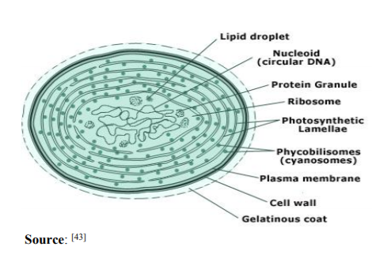
The water used in the home for domestic purposes is also a contributing factor to eutrophication. Some public members agreed that soap and other detergents used for cleaning contain phosphates that initiate Eutrophication (Paerl, 2018). Domestic sewage is rarely treated. This implies that it will be either directly or indirectly channeled to the water bodies and introduces the phosphates that initiate the development of algal blooms. The other cultural eutrophication is caused by human activities that lower oxygen concentration in bottom water. This condition is hypoxia and has adversely affected aquatic life.
- Effects of Eutrophication on Aquatic Life
When eutrophication is mentioned, people think of the dominance of thick green coloration on the water surface that results in fish's death. Generally, fish is the most affecting aquatic organism by the growth of cyanobacteria in water. The depletion of oxygen, a condition is known as hypoxia, is common whenever eutrophication exists. Both fresh water and seawater fishes are directly affected by eutrophication but are more pronounced in freshwater lakes (Demeke, 2016). Oxygen is needed to sustain life on the earth, and it is produced by the plan in the process of photosynthesis.
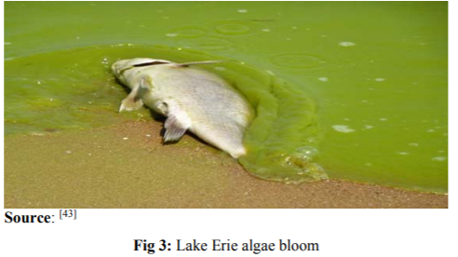
The growth and establishment of algal blooms in the eutrophicated water make algae grow at an alarming rate, blocking the sunlight from reaching other organisms and decreasing the oxygen levels. The algae also die due to unfavorable conditions, and this results in the bacteria acting on them to consume the oxygen and get temporarily hypoxic (Paerl, 2018). In anaerobic conditions, stationary mats of water hyacinths develop by shading from the bottom of the growing vegetation ad this has a great impact on the deprivation of fish species, food, and spawning grounds. Water hyacinths are common in South America and Native to the Amazon Basin (Demeke, 2016). Water hyacinth arrived in the lakes by River and tributaries through the disposal of unwanted aquarium plant by traditional boating. In Africa, Lake Victoria has been experiencing high levels of water hyacinth. Individuals living along the lakes experiencing water hyacinth are much knowledgeable on its causes and impacts on aquatic life.
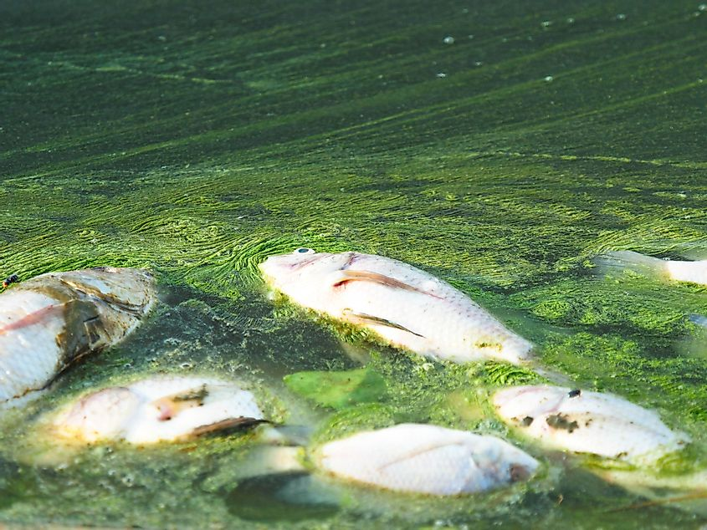
Fig 1.2: Eutrophication leading to death of fish (Earthhow, 2021).
The other essential information regarding the effects of eutrophication on aquatic life is the growth and development of cyanobacteria. The blue-green algae cause greater harm to aquatic life (Maberly et al., 2020). Some of the blue-green algae produce toxins that affect the bird and animals. The aquatic population has been declining in the previous decades due to the mass death of fish, birds, and other animals. Approximately 100 million aquatic animals die each year from water pollution. Surprisingly, numerous marine and freshwater animals get entangled with plastics, and when eutrophication occurs, the rate of animal death is alarming (Maberly et al., 2020). 90% of wastes are killing aquatic life by initiating eutrophication or informing of plastic that entangles the animals from rivers that end in the lakes or oceans.
- Effects of cyanobacteria on humans
The blue-green algae are commonly known by people, especially in the habitats of polluted lakes and oceans. Biologists also have dense information regarding cyanobacteria. The most important aspect of cyanobacteria can be understood by examining the harms the blue-green algae pose to human beings (Gardner et al.,2017). There is cyanobacterial harmful algal bloom (cHAB), which develops when water is warm, moving slowly, and has nutrients. The algal blooms are easily manifested when the conditions are favorable. A coating of extraneous foul stuff floats on the water surface, which is common during late summer or early fall, although it occurs at any time of the year. Most algal blooms are much harmful as they consist of toxins. However, not all algal blooms are harmful to humans. The harmful blooms have cyanotoxins that contain the following common toxins; Anatoxin-a, nodularin, microcystin, saxitoxin, lyngbyatoxin, and cylindrospermopsin.
Human exposure to cHAB is by three common routes. Ingestion, which is swallowing contaminated or consuming contaminated sea animals. Bioaccumulation has already occurred through the accumulation of the toxins mentioned above in a particular organism. As the food chain moves to higher levels, the concentration of toxins increases, a condition known as biomagnification is evident (Maberly et al., 2020). The cHAB also gets in the human body through inhalation through breathing aerosolized toxins. Humans might as well get have the cHAB in their bodies through direct skin contact with contaminated water when swimming or boating. Children are mostly exposed to these harmful conditions since they have little knowledge of the possible harms of the contaminated water.
Clinicians have discovered that there are many signs and symptoms associated with cHAB. In the digestive system, the major impacts of the toxins include nausea, diarrhea, mid-liver enzyme elevation, and vomiting. These symptoms might show in 3-5 hours after ingesting the cHAB. In some people, the complete manifestation of the infection might take 1-2 days (Maberly et al., 2020). The exposure might result in conjunctivitis, rhinitis, earache, soft throat, and swollen lips. The respiratory system might as well bear harms that include atypical pneumonia and hay fever-like syndrome. Electrolyte imbalances also result in headaches, joint pain, and general muscle weakness. The worst effect of the cHAB on humans is initiating hepatic failure due to Microcystins present in the water (Qin et al., 2015). On rare occasions, the patient experiences proteinuria or hematuria. The exposure of cHAB to the eyes results in conjunctivitis, swelling, and photophobia. Clinicians are committed to improving the quality of human lives, which is done effectively by offering evidence-based medication through diagnosis. The common diagnostic criteria for cHAB include electrolytes and liver function tests, renal tests to confirm proteinuria, and glycosuria (Hamilton, Salmaso, & Paerl, 2016). The respiratory symptoms are effectively examined using radiography. Laboratory tests are also used to confirm cyanobacteria in the feces, tissue serum, and water specimen. Immediate medication is needed; otherwise, the combination of the numerous signs and symptoms from cHAB will lose lives (Maberly et al., 2020). The increased incidences of bioaccumulation and biomagnification have resulted in the development of cancer infections of different kinds. However, a very small percentage of people have information on the intense effects of eutrophication on human health.
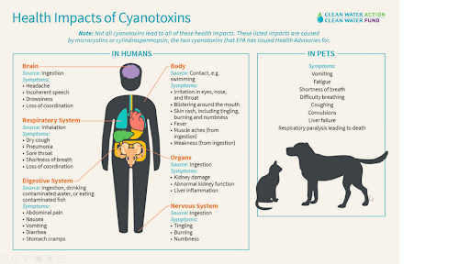
Fig 1.3: Effects of Eutrophication on humans and domestic animals.

d. Effects Eutrophication on Animals
Just like humans, animals have cells and tissues that are susceptible to illnesses. The cHAB affects not only the aquatic animals but also the terrestrial animals due to the consumption of the intoxicated animals. Generally, animals are exposed to toxins in some ways humans are; through ingestion and skin contact (Demeke, 2016). Domestic animals are affected by the cHAB since they can never differentiate between contaminated and clean water. In this regard, some domestic animals have been affected intensively by the toxins. This results in death following the fact that the world has poor healthcare services for domestic animals.

Review Major Efforts to Mitigate or Reverse Eutrophication
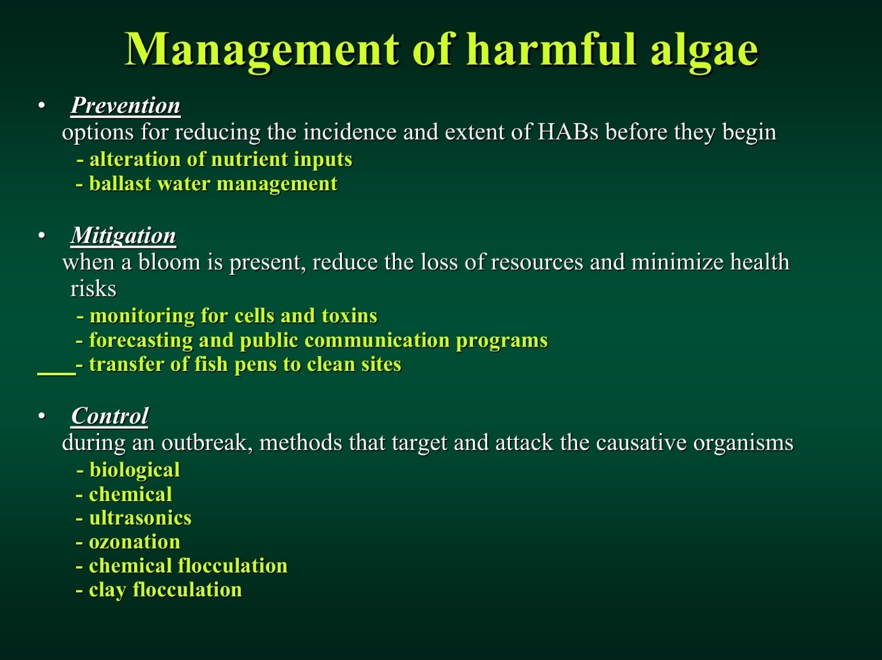
Fig.1.4: Management of harmful algae (Earthhow, 2021).
Eutrophication sets off a chain in the ecosystem, starting with the overabundance of algae and plants. Managing eutrophication implies that the health effect of the disturbance will be reduced, the death of aquatic organisms will be managed to improve the survival rates of the animals (Qin et al., 2015). Mitigating the eutrophication makes the scientists focus on water bodies without water hyacinth and algal blooms. The following efforts have marked the efforts to mitigate eutrophication in the recent past;
- Restructuring of Industrial layout
Industries produce many toxic substances that contain nitrogen and phosphates that lead to the development of cyanobacteria. The sewage treatment removes impurities from the water before it is discharged into the main water bodies. The industries are forces to lay down sewage treatment centers that control all the toxins from affecting aquatic lives. Industries are being warned of the effects of disposing of their wastes without passing them to septic tanks (Maberly et al., 2020). There are three essential steps of sewage treatment, including pre-treatment. This stage consists of materials being eliminated from the water wastes. Many larger materials, including nails, plastics, and other plant objects, are eliminated. The primary treatment is aimed at separating the organic matter and sludge from the rest of the water. All the organic components are eliminated (Maberly et al., 2020). The next phase is the secondary treatment that breakdown the bacteria in water. The last step in sewage treatment is the tertiary stage. This is marked by removing all the inorganic components like nitrogen and phosphorus that are directly harmful to aquatic biota and indirectly harmful to humans. In controlling eutrophication, this is the essential step since the nitrates and phosphates are eliminated. All the industry layouts should design with sewage treatment plants or else channel their wastes to a common septic tank for treatment.
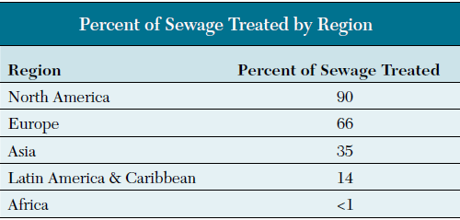
Fig.1.5: Percent of sewage treated by region
- Management of Agricultural practices.
The farm catchment has made it easier to control the source point of phosphorus and, as a result, curbing pollution on the water bodies. Farm management practices have been initiated in large-scale farms, focusing on using sound fertilizer application and nutrient handling with effective timing (Ma et al., 2015). The necessity of this action is to moderate the phosphorus levels in the soil, and thus the amount that will be leached to the ground will be minimal. The farmer needs to use manure more often than fertilizers. Manure is natural with a smaller number of inorganic molecules than fertilizers with high percentages of concentrated phosphates and nitrates. Researchers have raised a serious concern about aquaculture's effects on water pollution and generally affecting the aquatic biota (Ma et al., 2015). Of all the farming practices, fish keeping in lakes and portions of oceans fenced with nets supplies large amounts of nitrogen and phosphorus-rich substances in water. This dangerous practice is being replaced with the traditional fish pond to prevent eutrophication.
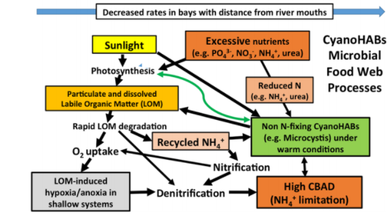
- Composting
According to Ma et al. (2015), composting is converting organic matter like food residues and decaying vegetation into compost manure. The nutrients present in manure are deficient in the inorganic nitrates and phosphates, the main components of algae and other associated microbes in the water bodies (Ma et al., 2015). Compost fertilizers are safer for crop farming since all the essential elements are broken down and synthesized by plants, thus not adding up in the cycle of eutrophication.

- Reducing Pollution
Limiting pollution is an easy and effective method to reduce the supply of nitrates and phosphates in the water systems (Gardner et al.,2017). The big manufacturing companies and industries are responsible for mitigating pollution and all the people by managing the domestic wastes.
- Strengthening Laws and Regulations Against Non-Point Pollution
Governments of the world nations have been showing concern on pollution by passing laws and regulations that control water pollution and substantially curb eutrophication. Non-point pollution is hard to control in managing nutrient entry into water systems (Paerl, 2018). If the nutrient sources are effectively managed, eutrophication will subsequently reduce. Some laws target enhancing high quality water standards besides zero-tolerance to the non-point solution. For the set goals to be met, the stakeholders, including policymakers, citizens, and pollution regulation agencies, need to cooperate (Qin et al., 2015). Taking actions against the lawbreakers will ensure eutrophication is managed effectively. The U.S environmental protection agency (EPA) mentioned that at least $ 100 billion is used annually by the Federal government to mitigate the pollution. Water pollution in which eutrophication is categorized takes a greater portion of the allocated money.
- Public Education
As it is revealed in the public viewpoint, only a smaller percentage of the public members are well informed on eutrophication and the potential harms it has on humans. Mitigating eutrophication is not solely for ecologists but for all global citizens. The agriculturalists have been educated on harmful farming practices. For instance, farmers have been constantly reminded that manure has fewer effects on aquatic lives than fertilizers. More essentially, the connections between cyanobacterial toxins and human infections are clearly stated in the USA (Maberly et al., 2020). This education promotes their understanding of the best practices for reducing water pollution. The efforts to mitigate eutrophication have been boosted by the availability of social media platforms like Facebook, Twitter, Snapchat, and Instagram that pass information and attached videos and photographs on the best actions of mitigating water pollution and, more essentially, Eutrophication (Maberly et al., 2020). Nations have been investing in education by ensuring that the number of people enrolling in aquatic life management courses has increased. For example, water management, sewage management, zoologists, and pollution and control. These courses will ensure many specialists are focusing on eliminating eutrophication and management of aquatic life.

Strength and Weaknesses of Mitigation
Strengths
The main strengths in the mitigation of eutrophication have been revealed by the union of many nations worldwide. Every nation in the world has committed environmental organizations. For example, in the USA, Environmental Protection Agency (EPA) is praised for cleaning the environment and enforcing policies to curb eutrophication. Besides, the United Nations Environmental Program (UNEP), a major strength, is committed to nutrient management and extending education to the public on the effect of Eutrophication (Paerl, 2017). The other major strength of the mitigation programs is composting. Through composting, few inorganic components get into the soil, and this prevents eutrophication. It is interesting to see the progress of water pollution elimination through the use of social media platforms. The users of social media platforms around the globe are numerous. This is the best way of disseminating information on the best eutrophication management practices. People can easily put pollution mitigation ideas into practice and thus boosting the efforts if eliminating the problem. Law enforcement is another significant strength in preventing water pollution (Maberly et al., 2020). Every country in the world has environmental agencies committed to ensuring general biota is not affected by pollution. Fines and court sentences and exposed to the lawbreaker. Lastly, new policies are being developed, proving that the existing ones are being strengthened, and new solutions are being offered to mitigate the problem.
Weaknesses
The major weakness in the eutrophication mitigation programs is the lack of public support. Most agencies like UNEP and the EPA face criticism from the public for taking firm actions against environmental polluters. As well, the number of educated specialists for mitigating eutrophication is limited. This implies that their efforts to manage the establishment of algal blooms in the water bodies will not be effectively met. Besides, some law enforcement agents are corrupt and can allow companies and industries to dispose of their harmful waste and get financial benefits in return (Paerl, 2017). Lastly, the funds allocated for environmental management are insufficient to cater to all forms of pollution. In this regard, water purification might be poorly done, and the effectiveness in mitigating eutrophication is not met as expected.

Conclusion
In summation, the onset of eutrophication was in the 1940s in England and wells when it was discovered that the water bodies, especially the lakes, had developed blue-green algae. The public is somewhat knowledgeable on eutrophication causes as disposal of inorganic wastes in the water bodies. However, only committed researchers to have a better understanding of the issue in depth. The most common thing about eutrophication that most members know of the public is its health effects on humans and causing death in aquatic animals (Hamilton, Salmaso, & Paerl, 2016). Efforts of mitigating the problem are marked by clearly existing laws on o water pollution, ensuring that all the companies have well-developed septic tanks which channel the wastes to purification plant to remove the inorganic waste, and more essentially public education on better ways of controlling water pollution. The mitigation programs are interconnected between the world, and this makes it easy to control pollution globally. In the converse, the UNEP and other environmental management agencies lack sufficient funds to eliminate eutrophication.
The most important part of this paper is the definition of eutrophication. Eutrophication refers to the gradual increase in the concentration of mineral ions, especially nitrogen, phosphorus, and sulfates, in an aging aquatic ecosystem like lakes (Qin et al., 2015). Human activities are the primary causes of cultural eutrophication. For example, clearing land has enabled runoff water to carry the nitrates and phosphates into the water bodies, aquaculture, fertilizers in the farming practices, and poor disposal of industrial and domestic wastes. The presence of nitrates and phosphates motivates algae to develop hurriedly, especially when water is warm and slightly saline. The cyanobacteria take over the water surface and deplete oxygen, thus dealing with the death of fishes and other water species. Humans are infected when they drink the cHAB toxins (Paerl, 2017). Generally, the toxins are spread within the living organism through the food chains and food webs, bioaccumulation, and biomagnification as the dominant factors (Qin et al., 2015). Eutrophication mitigation power is vested in UNEP and EPA in the USA. However, every country has well-established programs to eliminate the existing global controversy. The other interesting part of the paper is that joined efforts can lead to the elimination of eutrophication. Using modern technology, evidence-based practices on the mitigation of global issues can be easily disseminated and initiated.
The future of eutrophication lies in the hand of UNEP or EPA and all the citizens in the world. Limiting the use of organic fertilizers and concentrated animal feed can help in minimizing eutrophication. Discharging the industrial wastes in sewage treatment plants to remove inorganic nitrates and phosphates is a better plan in preventing Eutrophication (Qin et al., 2015). Fishkeeping should be simplified and aquaculture eliminated as it inputs much nitrogen and phosphorus in the aquatic systems. At the domestic levels, the families need to dispose of sewages in the right channels apart from channeling it directly to the water bodies.
In my opinion, humans are the enemies of nature. Most of the harms affecting other living organisms are initiated by a human. The best practice for curbing eutrophication is educating the public on the best ways of disposing of all the wastes. Quality education is needed by the bio life management specialist on effective ways of reducing water pollution and, more essentially, preventing the formation of algal blooms. People need education on the need for using phosphorus-free detergents and fertilizers to minimize nutrient-rich runoff. The pond management specialists should apply phosphorus-binding products to lower the nutrients available in water, limiting algal growth. Lastly, researchers are expected to do comprehensive research on better mitigating eutrophication and offer more acceptable solutions for curbing the problem.

References
Demeke, A. (2016). Cyanobacteria blooms and biological control methods. International Journal of Fauna and Biological Studies, 3, 32-38.
Ding, S., Chen, M., Gong, M., Fan, X., Qin, B., Xu, H., ... & Zhang, C. (2018). Internal phosphorus loading from sediments causes seasonal nitrogen limitation for harmful algal blooms. Science of the total environment, 625, 872-884.
Earthhow. (2021). How Does Eutrophication Work? Causes, Process and Examples. Retrieved from. https://earthhow.com/eutrophication-causes-process-examples/
Gardner, W. S., Newell, S. E., McCarthy, M. J., Hoffman, D. K., Lu, K., Lavrentyev, P. J., ... & Paerl, H. W. (2017). Community biological ammonium demand: a conceptual model for Cyanobacteria blooms in eutrophic lakes. Environmental science & technology, 51(14), 7785-7793.
Hamilton, D. P., Salmaso, N., & Paerl, H. W. (2016). Mitigating harmful cyanobacterial blooms: strategies for control of nitrogen and phosphorus loads. Aquatic Ecology, 50(3), 351-366.
Huang, J., Zhang, Y., Huang, Q., & Gao, J. (2018). When and where to reduce nutrient for controlling harmful algal blooms in large eutrophic lake Chaohu, China?. Ecological Indicators, 89, 808-817.
Ma, J., Qin, B., Wu, P., Zhou, J., Niu, C., Deng, J., & Niu, H. (2015). Controlling cyanobacterial blooms by managing nutrient ratio and limitation in a large hyper-eutrophic lake: Lake Taihu, China. Journal of Environmental Sciences, 27, 80-86.
Maberly, S. C., Pitt, J. A., Davies, P. S., & Carvalho, L. (2020). Nitrogen and phosphorus limitation and the management of small productive lakes. Inland Waters, 10(2), 159-172.
Paerl, H. W. (2017). Controlling harmful cyanobacterial blooms in a climatically more extreme world: management options and research needs. Journal of Plankton Research, 39(5), 763-771.
Paerl, H. W. (2018). Mitigating toxic planktonic cyanobacterial blooms in aquatic ecosystems facing increasing anthropogenic and climatic pressures. Toxins, 10(2), 76.
Qin, B., Li, W., Zhu, G., Zhang, Y., Wu, T., & Gao, G. (2015). Cyanobacterial bloom management through integrated monitoring and forecasting in large shallow eutrophic Lake Taihu (China). Journal of hazardous materials, 287, 356-363.
Xiao, Q., Xu, X., Duan, H., Qi, T., Qin, B., Lee, X., ... & Zhang, M. (2020). Eutrophic Lake Taihu as a significant CO2 source during 2000–2015. Water research, 170, 115331.

